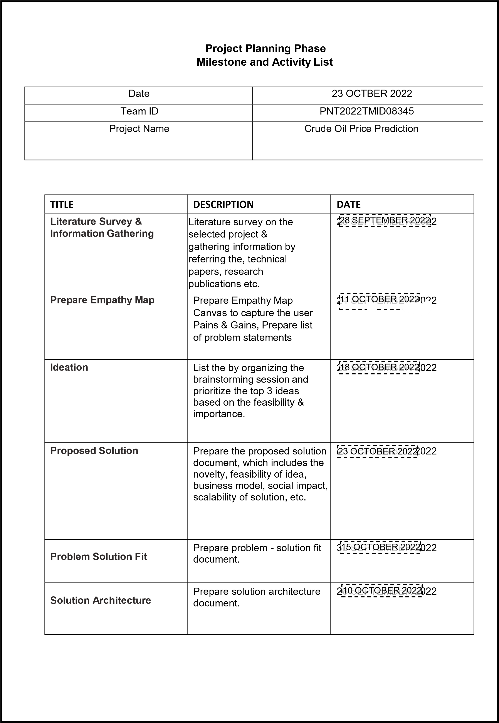

PNT2022TMID08321

|  |  |  |  |  |  |  |  |  |  |  |  |  |  |  |  |  |  |  |  |  |  |  |  |  |  |  |  |  |  |  |  |  |  |  |  |  |  |  |  |  |  |  |  |  |  |  |  |  |  |  |  |  |  |  |  |  |  |
| --- | --- | --- | --- | --- | --- | --- | --- | --- | --- | --- | --- | --- | --- | --- | --- | --- | --- | --- | --- | --- | --- | --- | --- | --- | --- | --- | --- | --- | --- | --- | --- | --- | --- | --- | --- | --- | --- | --- | --- | --- | --- | --- | --- | --- | --- | --- | --- | --- | --- | --- | --- | --- | --- | --- | --- | --- | --- |
| |  |  |  |  |  |  |  | | --- | --- | --- | --- | --- | --- | --- | | **Customer Journey** | Prepare the customer journey maps to understand the user interactions & experiences with the application (entry to exit). | 2 | 90 OCTOBEROCTOBER 2022 20 | | 22 | | |  | | | **Functional Requirement** | Prepare the functional requirement document. | 8 | 20 OCTOBER OCTOBER 2022 2022 | | |  | |  | | | | **Data Flow Diagrams** | Draw the data flow diagrams and submit for review. | 9 | 23 OCTOBER OCTOBER 2022 2022 | | |  | |  | | | | **Technology Architecture** | Prepare the technology architecture diagram. | 1 | 260 OCTOBER OCTOBER 2022202 | | | 2 | |  | | | | **Prepare Milestone &**  **Activity List** | Prepare the milestones & activity list of the project. |  | 2226 OCTOBEROCTOBER 2022 202 | | | 2 | |  | | | | **Project Development -**  **Delivery of Sprint-1, 2, 3 & 4** | Develop & submit the developed code by testing it. | I | NIN PROGRESS.. PROGRESS..... |  | | | |  | |